*employee* (*ID*, *person_name, street, city*) *works* (ID, *company_name, salary*)

Figure 1

1. (20%) Consider the employee database with two relations in Figure 1.
   1. Write a function **avg_salary** that takes a company name as an argument and finds the average salary of employees at that company.

Select avg(salary) as avg_salary

From works

Group by company ;

* 1. Write an SQL statement, using the **avg_salary** function, to find companies whose employees earn a higher average salary than the average salary at“FirstBank”.

Select company

From works

Group by company ;

having avg(salary) > ( Select avg(salary) From works Where company_name = ‘FirstBank’ Group by company)

1. (20%) Design a database using the ER-diagram for an airline. The database must represent the information of each **flight (航班)**, including its flight number and schedules (起飛降落的日期時間). The database also needs to keep track of **customers** and their **reservations** on individual flights,

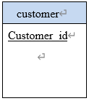including the status and seat assignments. (Design the proper entity sets and relationship sets. For each entity set, represent the proper primary key and attributes.)

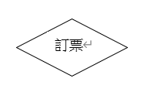

1

Has booked

|  |
| --- |
| book |
| Customer_id  flight_number  status  seat |

n

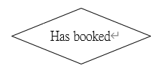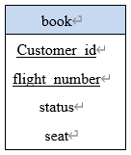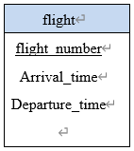

n

1

1. (20%) Construct appropriate relational schemas for the E-R diagram in Figure 2. For each relational schema, represent the proper attributes and primary key.

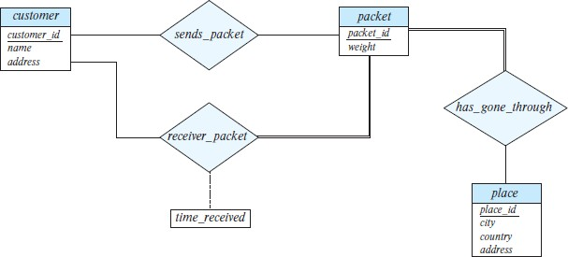

Figure 2

1. (20%) List two nontrivial functional dependencies satisfied by the relation in Figure 3. Explain your answer.

|  |  |  |
| --- | --- | --- |
| **A** | **B** | **C** |
| a1 | b1 | c1 |
| a1 | b1 | c2 |
| a2 | b1 | c1 |
| a2 | b1 | c3 |

A → B and C → B

Figure 3

1. (20%) Consider the schema R = (A, B, C, D, E, G) and the set F of functional dependencies as follows:

{AB → CD, B → D, DE → B, DEG → AB, AC → DE}.

* 1. Prove that AB is not a superkey

1.result = AB

2.result = ABCD

3.result = ABCDE

4.result = no more

Because : ABCDE != R

So : AB is not a superkey

* 1. Prove that DEG is a superkey.

1. result = DEG 2.
2. result = ABDEG
3. result = ABCDEG(all)

Because ABCDEG = R

So DEG is a superkey

繳交作業方式：Please submit your homework in a single PDF file to TronClass by 1/9/2022 11:59pm.